ЗАДАТАК: Креирати класу Class1 и две апликације.
а) Kреирати апликацију у којој се насумично исцртавају објекти, а исцртавање се покреће и зауставља кликом миша.
b) Kреирати апликацију која мења величину Class1 објекта (смањује или повецава) кликом на форму.

Аутори задатка: Стефан Радојичић и Андреј Милисављевић, Математичка гимназија, IIIц, школска 2018/2019. година

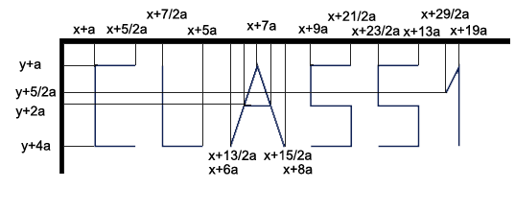
using System.Drawing;

class Class1
{
Point o;
int a;
Color boja;

public Class1(Point o, int a, Color boja)
{
this.o = o;
this.a = a;
this.boja = boja;
}

public Class1(Point o, int a)
{
this.o = o;
this.a = a;
this.boja = Color.Black;
}

public Class1(Point o)
{
this.o = o;
this.a = 30;
this.boja = Color.Black;
}

public void Uvecaj()
{
a += 1;
}

public void Smanji()
{
a -= 1;
}

public void Premesti(int s, int v, Random r)
{
o.X = r.Next(a / 2, s - a / 2);
o.Y = r.Next(a / 2, v - a / 2);
}

public void Crtaj(Graphics g)
{
Pen olovka = new Pen(boja, 2);
Point[] c = new Point[4];
c[0] = new Point(o.X + 5 * a / 2, o.Y + a);
c[1] = new Point(o.X + a, o.Y + a);
c[2] = new Point(o.X + a, o.Y + 4 * a);
c[3] = new Point(o.X + 5 * a / 2, o.Y + 4 * a);
Point[] l = new Point[3];
l[0] = new Point(o.X + 7 * a / 2, o.Y + a);
l[1] = new Point(o.X + 7 * a / 2, o.Y + 4 * a);
l[2] = new Point(o.X + 5 * a, o.Y + 4 * a);
Point[] A = new Point[3];
A[0] = new Point(o.X + 6 * a, o.Y + 4 * a);
A[1] = new Point(o.X + 7 * a, o.Y + a);
A[2] = new Point(o.X + 8 * a, o.Y + 4 * a);
//A[3] = new Point(o.X + 13 * a / 2, o.Y + 5 * a / 2);
//A[4] = new Point(o.X + 15 * a / 2, o.Y + 5 * a / 2);
Point[] s1 = new Point[6];
s1[0] = new Point(o.X + 21 * a / 2, o.Y + a);
s1[1] = new Point(o.X + 9 * a, o.Y + a);
s1[2] = new Point(o.X + 9 * a, o.Y + 5 * a / 2);
s1[3] = new Point(o.X + 21 * a / 2, o.Y + 5 * a / 2);
s1[4] = new Point(o.X + 21 * a / 2, o.Y + 4 * a);
s1[5] = new Point(o.X + 9 * a, o.Y + 4 * a);
Point[] s2 = new Point[6];
s2[0] = new Point(o.X + 13 * a, o.Y + a);
s2[1] = new Point(o.X + 23 * a / 2, o.Y + a);
s2[2] = new Point(o.X + 23 * a / 2, o.Y + 5 * a / 2);
s2[3] = new Point(o.X + 13 * a, o.Y + 5 * a / 2);
s2[4] = new Point(o.X + 13 * a, o.Y + 4 * a);
s2[5] = new Point(o.X + 23 * a / 2, o.Y + 4 * a);
Point[] uno = new Point[3];
uno[0] = new Point(o.X + 14 * a, o.Y + 2 * a);
uno[1] = new Point(o.X + 29 * a / 2, o.Y + a);
uno[2] = new Point(o.X + 29 * a / 2, o.Y + 4 * a);
g.DrawLines(olovka, c);
g.DrawLines(olovka, l);
g.DrawLines(olovka, A);
g.DrawLine(olovka, o.X + 13 * a / 2, o.Y + 5 * a / 2, o.X + 15 * a / 2, o.Y + 5 * a / 2); //A[3], A[4]
g.DrawLines(olovka, s1);
g.DrawLines(olovka, s2);
g.DrawLines(olovka, uno);
}

public Color VratiBoju()
{
return boja;
}

public int VratiX()
{
return o.X;
}

public int VratiY()
{
return o.Y;
}

public int VratiA()
{
return a;
}
}

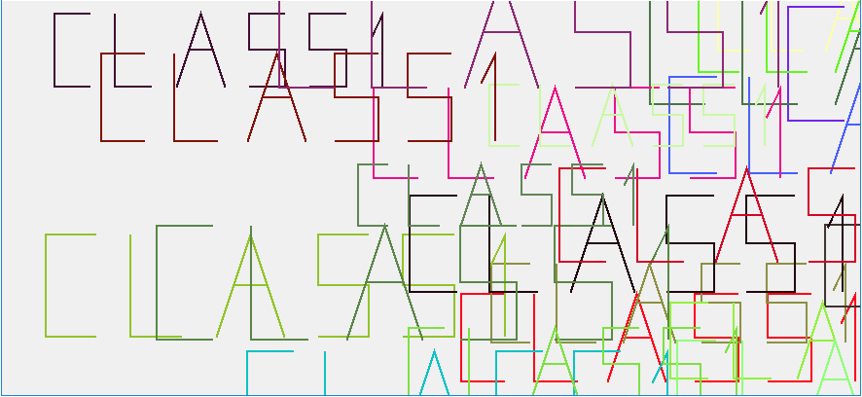

Class1[] class1 = new Class1[30];
int n = 0;
Random r = new Random();

private void Form1_Paint(object sender, PaintEventArgs e)
{
for (int i = 0; i < n; i++) class1[i].Crtaj(e.Graphics);
}

private void Form1_Load(object sender, EventArgs e)
{
Postavi();
}

private void Postavi()
{
n = r.Next(5, 30);
for (int i = 0; i < n; i++)
{
int a = r.Next(20, 40);
int x = r.Next(-a * 2, ClientRectangle.Width - a * 2);
int y = r.Next(-a * 2, ClientRectangle.Height - a * 2);
Color boja = Color.FromArgb(r.Next(255), r.Next(255), r.Next(255));
class1[i] = new Class1(new Point(x, y), a, boja);
}
}

private void timer1_Tick(object sender, EventArgs e)
{
Postavi();
Refresh();
}

private void Form1_MouseClick(object sender, MouseEventArgs e)
{
timer1.Enabled=!timer1.Enabled;
}
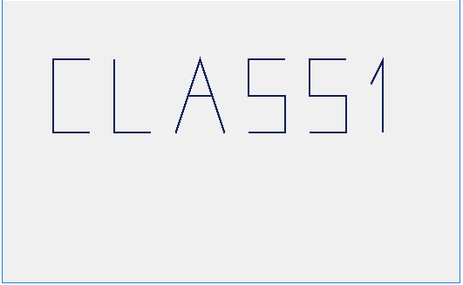

Class1 class1;
Random r = new Random();
bool p = true;

private void Form1_Load(object sender, EventArgs e)
{
int a = r.Next(1, 10);
int x = r.Next(-a*10, ClientRectangle.Width/2 - a / 2);
int y = r.Next(-a*10, ClientRectangle.Height/2 - a / 2);
Color boja = Color.FromArgb(r.Next(256), r.Next(256), r.Next(256));
class1 = new Class1(new Point(x, y), a, boja);
timer1.Start();
}

private void Form1_Paint(object sender, PaintEventArgs e)
{
class1.Crtaj(e.Graphics);
}

private void timer1_Tick(object sender, EventArgs e)
{
Refresh();
if (p) class1.Uvecaj();
else class1.Smanji();
}

private void Form1_MouseClick(object sender, MouseEventArgs e)
{
p = !p;
}

